

**Stewarts Agri-Tech Glasshouse**

**End of Project Report**

**June 2020**

**Project Summary**

Dorset has a long and proud tradition of horticulture, contributing to the region’s beautiful landscape and economy. Stewarts is an established family-owned and well-respected horticultural business which has been growing plants in Dorset since 1865 and at the Broomhill site since the 1960’s.

Stewarts is a vertically integrated horticultural business. Stewarts currently operates a small-scale, inefficient and inflexible nursery at its Broomhill site in countryside near Wimborne.

Nursery activities at Broomhill have decreased from 30,000 sqm in 2000 to 4,800 sqm currently, with all current growing undertaken in 1980s infrastructure. Stewarts relies heavily on its image as a plant producer (“We grow plants”).

Huge investment by large-scale growers (especially in Holland) has increasingly made the Broomhill nursery operationally inefficient and with sub-optimal productivity.

Despite having its own nursery operations, Stewarts is currently heavily reliant on purchasing plants from third parties – with around 91% (by value) purchased from third parties (66% UK and 25% imported) in 2018/19. Poor materials handling is the primary reason for the operational inefficiencies, involving labour intensive repetitive physical work at ground-level.

Overview of the Stewarts Agri-Tech Glasshouse project:

* + 10,000 sqm growing facility, which will be public-facing and available to be toured by groups and individuals.
  + Agri-Tech features with improved automated materials handling and computer-controlled varied heating and shading zones.
  + Significantly increased productivity and more sustainable horticultural production.
  + Range of plants capable of being produced increased by a factor of 4x.
  + Allow Stewarts to easily react to changes in trends and demand.
  + Enable Stewarts to substantially lower its carbon footprint through decreasing its current heavy reliance on third party plants that are transported from around the UK and, if imported, tend to originate from the Netherlands.
  + Creation of an Educational Facility at Broomhill with Kingston Maurward College engaged as a project ‘partner’.

In June 2019, **Dorset Local Enterprise Partnership allocated £297k of grant funding to support the construction of an innovative and highly productive growing facility**, incorporating Agri-tech features, low carbon initiatives and an educational facility.

|  |  |
| --- | --- |
| Project start date | 1st June 2019 |
| Project construction start date | 1st September 2019 |
| Project completion date | 31st March 2020 |
| Project construction completion date | 30th November 2020 |

**Outputs and Outcomes:**

The project has created 10,000sqm of new commercial space and safeguarded 13 jobs, with the glasshouse structure now fully constructed. There were delays to the project due to the volume of rainfall in Q4 2019 and also due to the Covid-19 pandemic. The fit-out of the glasshouse is being undertaken with forecast completion September 2020 and commissioning of the ground source heat pump estimated November 2020. Upskilling of the existing 13 employees is on target to be achieved by March 2021.



Figure : Development site (April 2019)

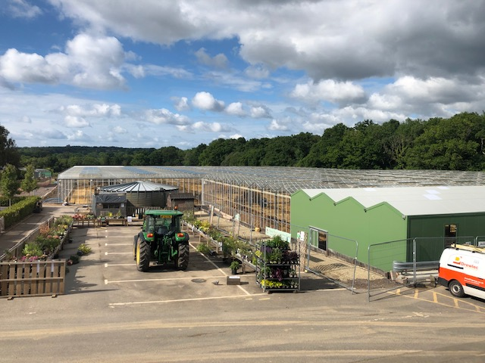

Figure : Site at construction completion stage (June 2020)

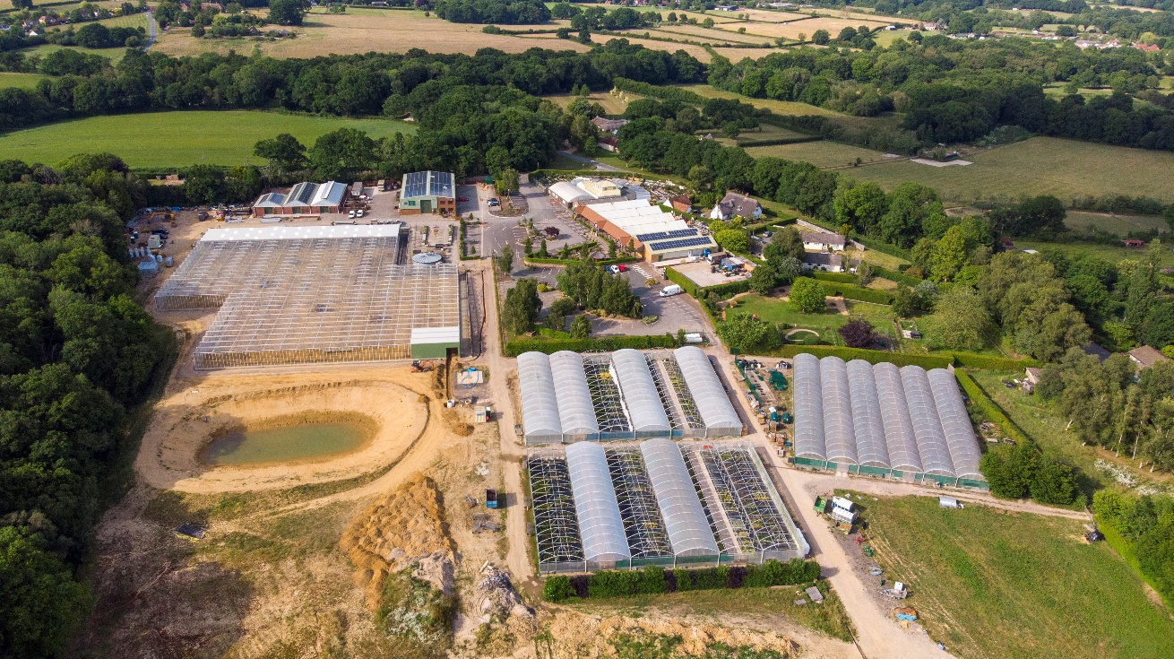

Figure 3: Aerial view of site (June 2020)

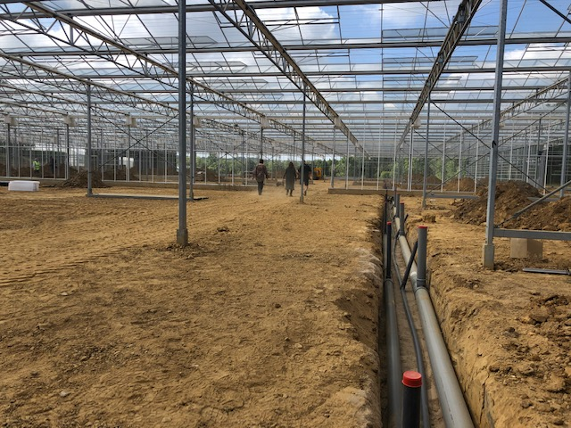  
  
Figure 4: Commencement of internal fit-out (June 2020)

Agri-Tech Glasshouse Fully Operational: 1st January 2021

Land unlocked (HA): 1.0

New commercial floor space (m2): 10,000m2

First batches of production from Growing Facility: 31st March 2021

Growing Facility open to the public: 15th April 2021

Educational Facility open to the public: 1st September 2021

The following outcome are projected to be delivered by 31st March 2025:

|  |  |  |  |  |  |  |  |
| --- | --- | --- | --- | --- | --- | --- | --- |
| **INDICATORS** | **OUTCOMES FORECAST** | | | | | | |
| **AGREED OUTCOMES** | **FY**  **20/21** | **FY**  **21/22** | **FY**  **22/23** | **FY**  **23/24** | **FY**  **24/25** | **TOTAL** |
| **Jobs created** | **5** | 0 | 3 | 1 | 1 | 0 | **5** |
| **Jobs safeguarded** | **13** | 13 | 0 | 0 | 0 | 0 | **13** |
| **Jobs upskilled** | **13** | 13 | 0 | 0 | 0 | 0 | **13** |
| **Volunteers** | **11** | 0 | 2 | 5 | 2 | 2 | **11** |
| **Work placements** | **20** | 0 | 2 | 6 | 6 | 6 | **20** |
| **General public footfall (no. of people)** | **87,658** | 0 | 6,250 | 13,125 | 26,906 | 41,377 | **87,658** |
| **Horticultural tours additional footfall** | **35,000** | 0 | 5,000 | 10,000 | 10,000 | 10,000 | **35,000** |
| **Educational facility additional footfall** | **8,750** | 0 | 1,250 | 2,500 | 2,500 | 2,500 | **8,750** |

This project will significantly increase productivity and create a more sustainable long-term horticultural production. The educational facility, in partnership with Kingston Maurward College, will create work placements with potential for progression to apprenticeships and trainee opportunities.

**Benefits Realised to date**

In addition to the safeguarded jobs, there has been an increase in interest in the site, particularly in relation to the ever-increasing focus and popularity of home-grown products and grow your own. This agri-tech glasshouse and education facility will be positioned to play an active role in this and cater for these demands.

**Lessons Learnt**

A high degree of planning was undertaken for the project and an external experienced horticultural specialist was appointed to oversee the technical aspects of the design and build. This has, and continues to be, a valuable support for Stewarts in delivering a highly productive state of the art growing facility.

One contractor was chosen to deliver a turnkey solution, incorporating the glasshouse construction and fit-out, including heating and irrigation systems, tabling and benching. This aided the efficiency of construction and project delivery.

Constructing the glasshouse during the winter months did result in delays to the project and added additional costs to level the site after the glasshouse had been constructed.

**Success Story**

Although the project fit-out is ongoing and the facility is not yet operational, there has been significant interest in the project and very positive feedback in relation to the project goals and objectives.

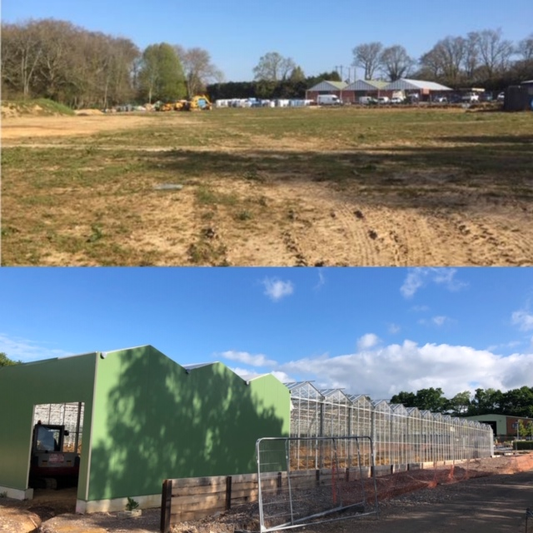

|  |  |
| --- | --- |
| **Dorset LEP**  Daniela Doncakova  [ddoncakova@bournemouth.ac.uk](mailto:ddoncakova@bournemouth.ac.uk)  Tel: 01202 962717  <https://www.dorsetlep.co.uk/stewarts-agritech-glasshouse> | **Stewarts Garden Centre**  Shaun Gomm, Project Consultant  [shaun@sg-financial.com](mailto:shaun@sg-financial.com)  Tel: 07775 710551  [www.stewarts.co.uk](http://www.stewarts.co.uk/) |