Institute for Medical Imaging and Visualisation

End of Project Report

July 2020

Project Summary
The Institute for Medical Imaging and Visualisation (IMIV) is bringing together stakeholders from research, education, healthcare services and systems, high value medical industries, and the creative industries. Once open, it will host and support a suite of educational programmes, multidisciplinary research and practice. The IMIV will also directly create, and serve, high-skilled technical and clinical roles within the region, and will further research and generate intellectual property in areas of particular relevance to the regional needs. Acting as a regional hub with global significance, the eco-system IMIV is creating, will drive commercial development of related intellectual property, in order to act as a catalyst for regional economic development related to medical science.

The IMIV will also address the skills gap in higher level technical provision, particularly in STEM areas such as radiography. This will provide regional employers with the skills they need, boosting productivity, as well as addressing social mobility by encouraging a greater take up of higher level technical education. The IMIV will also contribute to new medical product and intellectual property developments and house the research capacity for the next wave of 3D medical imaging development, informing the capability needs of industry, the healthcare sector and of technical education.
The £1.4m Dorset LEP funding has been used to fund the capital equipment needed to enable this development to commence at pace, specifically a 3T MRI scanner, 3D/4D ultrasound equipment, direct metal laser sintering machine and virtual reality equipment to help develop the next generation of clinical imaging and related diagnostic tools. State-of-the-art clinical data analytics techniques will be used, utilising existing in-house expertise, and developed collaboratively with local industry through investment in equipment. This will support the development of specialist skills within the region to support the innovation aspirations of the Dorset Clinical Commissioning Group and to secure expertise within the region in a post-Brexit era.

At the time of writing this report the capital purchases as a whole have been completed, which technically concludes the project from a Dorset LEP perspective. However, the equipment purchased and the accompanying research and educational programme is a long-term investment in healthcare research and innovation, which will take time to realise its full impact. The project as a whole has been severely impacted by the outbreak of COVID-19. The completion of the new Bournemouth University (BU) building in which IMIV is housed (Bournemouth Gateway Building), has been delayed by approximately 6 months. It has also delayed operationalisation of the equipment. That said, with a view to formally opening in January 2021, funding from DLEP has enabled the creation of a world-class team of scientists/specialists within Dorset and a transformation programme that is in train to deliver on the ambitions articulated above.

Change Request
The Project Team submitted a Change Request on 19th March 2019, requesting a three-month extension to the project duration. The extension to 30th June 2019 enabled the procurement to be MRI appropriately phased with the overarching development of the Bournemouth Gateway Building (BGB), where it will be sited. Furthermore, the extension allowed a more detailed options appraisal to secure the most effective tool to enable delivery of the project.

Outputs and Outcomes:
The following items of capital equipment were purchased with the funding:
- VR Equipment
- 3D Printer
- Sintering Machine
- Ultrasound scanner
- MRI Scanner
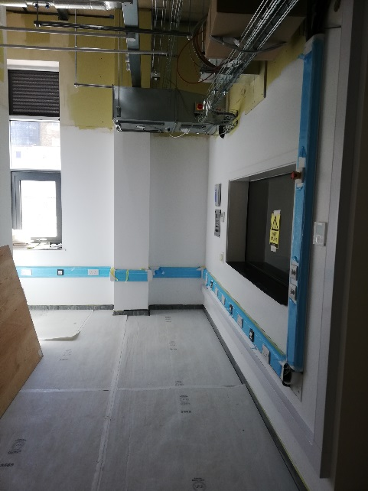
Detailed below are images of the MRI scanner being installed and the Sintering Machine in situ. The dedicated lab for the Sintering Machine is complete and the Sintering Machine has been delivered. Once the COVID-19 pandemic allows, all equipment will be installed and be operational.
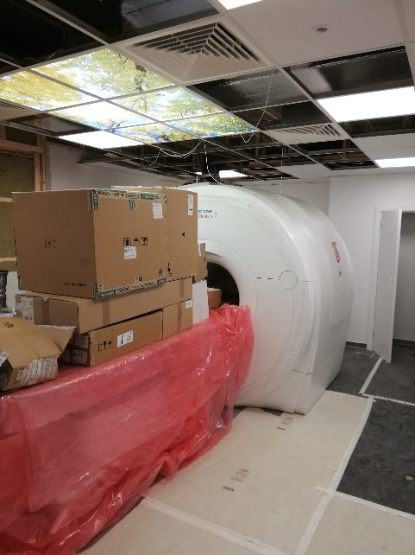

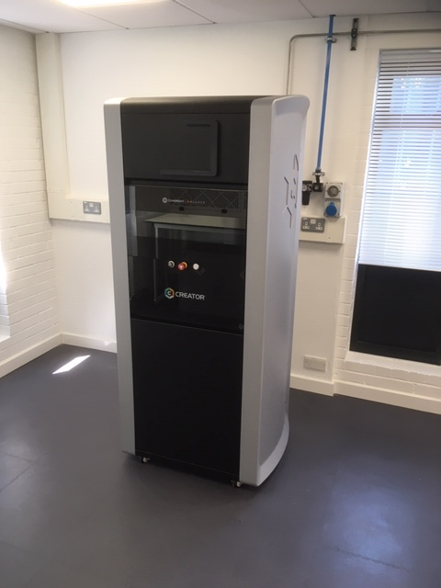
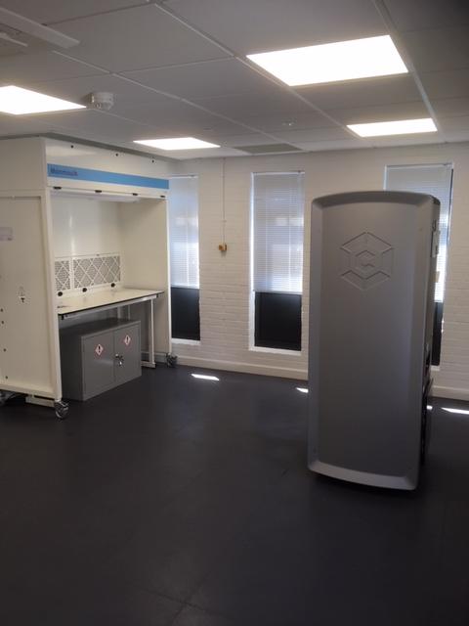
The intended outcomes of the project are as follows:
INDICATORS | OUTCOMES FORECAST
 | FY  20/21 | FY  21/22 | FY  22/23 | FY  23/24 | FY  24/25 | TOTAL
Direct jobs | 7 | 1 | 0 | 0 | 0 | 8
Indirect jobs | 0 | 0 | 0 | 1 | 1.4 | 2.4
New learners/Apprenticeships  70/30 split | 100 | 182 | 261 | 300 | 311 | 1154
Floor space created | 5000m2 | x | x | x | x | 5000m2
Unlocked land | 0.8HA | X | X | X | X | 0.8HA
Contribution to new product development: IP generation/ spin-off/ licensing  (new business start-ups) | 0 | 0 | 2 | 2 | 4 | 8
Additional public sector investment leveraged | 0 | 1 | 2.5 | 3 | 4 | £10.5m
Additional private sector investment leveraged | 0 | 0.25 | 0.5 | 2 | 2.5 | £5.25m
GVA from salaries to local economy | 0 | 500k | 500k | 500k | 500k | £2m

Progress towards these have been severely impacted by the outbreak of COVID-19 and the ensuing delays, however, IMIV has already created a number of benefits, which are detailed below.

Finances
Additionally, to the £1.4m Dorset LEP funding BU committed to provide match-funding to the value of £1,975,075, which has now been increased to £2,064,190.

Savings from the procurement of the non-MRI equipment were factored into the decisions that were taken around the MRI, and helped, in part, to secure the purchase of a new scanner as opposed to the originally targeted refurbished scanner.

Lessons Learnt
In this new area of research for BU, making full use of the combined knowledge of the stakeholder group, advisory group and the project design team/contractor to prepare the project brief proved to be valuable exercise. The value of broad and comprehensive consultation was a key lesson learnt and certainly something that we will seek to repeat. The decision to proceed with the MRI suite within a building that was already under construction required extensive risk management, but has proved to be a bold leadership decision and a significant achievement for both the University and the Dorset Local Enterprise Partnership.

For the imaging suite (MRI and US), one of the major risks was the potential for disruption to the construction of the Bournemouth Gateway Building. This was mitigated through the collaborative working by the Siemens (MRI scanner manufacturer) design team, BGB’s design team, Kier (BGB site contractor), Kier’s supply chain and University stakeholders/specialists. A milestone in this collaboration was the preparation of a feasibility study which examined each impact on BGB and the mitigation strategies that would need to be developed to achieve the desired outcome.

Success Story
Although, at the time of writing, the operationalisation of IMIV is severely impacted by the outbreak of COVID-19; the Institute already offers a demonstrable success for Dorset. The purchase of the equipment and establishing the IMIV has garnered engagement across the region, UK and globally, with the facilities and potential that it offers. It has enabled Bournemouth University to recruit a dedicated, world class team of scientists and associated staff (including the Head of Institute, Centre Manager, Senior Lecturer in Radiography and dedicated Institute Administrator, with further research and operational staff in the process of recruitment). In turn, this has led to the advancement of science in the area (detailed by the leading publications already produced) and the creation of pioneering new courses in medical imaging (including the MSc in Medical Imaging & Management).

Furthermore, it has centred and established dynamic new collaborations across Dorset, and beyond. This includes collaboration across Bournemouth University – in particular the world leading National Centre for Computer Animation (NCCA) and department for Creative Technology. The University has also focused recruitment strategy in other Faculties to recruit leading academics in aligned disciplinary areas, including a Professor of Neuroscience and a Senior Lecturer in Medical Image Analysis and Machine Learning – a strategic trajectory the institution plans to continue.

Beyond the University, it has advanced partnerships with the regional NHS trusts, which is laying the foundation for clinical collaboration and research partnerships, and ensuring the necessary skills development can be delivered within Dorset. This partnership development continues at pace, and includes – for example – targeted collaboration with partners in China.

Access to the facilities which the IMIV will offer is supporting the retention of research active clinical staff within Dorset. These collaborations will leverage public, private and third sector investment to the region as IMIV becomes operational, and is expected to lead to commercial growth opportunities. The Centre Manager appointed has extensive experience of developing commercial opportunities and IMIV has already been approached by myriad interested parties including SMEs and premiership football teams.

The funding to create IMIV has delivered an exceptional opportunity for Dorset and is already delivering with respect to creating a world leading research team and new educational programmes. It is also enabling the creation of partnerships around the world to further the knowledge base, skills and economic growth in Dorset. Further to the impacts of COVID-19 being mitigated, the fully operationalised IMIV is set to deliver a step change in medical imaging and visualisation, and with it, growth for Dorset in this critical area for societal advancement.
Construction contractors are:

Dorset LEP  Daniela Doncakova, Programme Manager  ddoncakova@bournemouth.ac.uk  Tel: 01202 962717  https://www.dorsetlep.co.uk/institute-for-MI-and-visualisation | Bournemouth University  Professor Stephen Tee, Executive Dean, Faculty of Health & Social Sciences  stee@bournemouth.ac.uk  Tel: 01202 962114  https://www.bournemouth.ac.uk/research/centres-institutes/institute-medical-imaging-visualisation

Depending on the on-going impact of COVID-19.

